 Computer Graphics – Mastery 2

# Objective

You will be creating your first triangle primitive in 2D space, hence forth known as NDC (Normalized Device Coordinates). The range of NDC by default goes from -1 and +1 on the X axis, -1 and +1 on the Y axis, -1 and +1 on the Z axis. Keep this in mind when creating the positions for your triangle vertices. Understand that these labs will need to use critical thinking and some creative decisions on your part on how to setup your code. Keep in mind the power point slides give you some direction on how to setup the shaders and use them as function pointers.

# Grading Breakdown

* 25% - Code Cleanup
  + Refactor your code so that it isn’t all in your main.cpp
  + You can make header files, classes, structures. Use critical thinking on how to make your code fit together!
* 50% - Rotating triangle (lines only)
  + This step involves using the **VERTEX** shader alongside your own vertex structure.
* 75% - Rotating triangle (filled to a solid color with white border lines)
  + This step will be introducing the barycentric formula to fill the triangle.
* 100% - Rotating triangle (interpolated colors with white border lines)
  + This step will involve the barycentric formula and the **PIXEL** shader to determine which color to use.

# Additional Challenge

1. Use two (and only two) linear interpolations to perform your Barycentric color interpolation. This can be a significant optimization.
2. Optimize the speed of your triangle fill routine even further by implementing Lari’s parametric triangle algorithm. You may implement your own as well, but it must be reasonably faster than “Better Brute” and cannot simply be plagiarized off of the internet.

# Setup

1. Clean up your code. This step involves creating header files, classes, and/or structures that contain specific functions or variables. For example, create a header file that contains your #defines, or create a class that contains your rasterizing functions.
2. Now that your code has been cleaned up, let’s go ahead and create a **VERTEX** structure. The **VERTEX** structure will contain 2 data members. The first will be an array of 4 floats. The second will be an unsigned integer for the color.
3. Create an array of 3 vertex structure objects, and define their information. Make sure to not exceed the bounds of NDC. For the color, make each verex a different value, preferable RED GREEN and BLUE.
4. Let’s keep in mind that we will need to do some coordinate conversions from NDC to SCREEN values to properly plot our pixels. This is a good time to create a function for doing so. Remember, we should keep our code neat, so we will need to place this function in one of the new header files we created.
5. Draw three lines connecting each VERTEX to make a triangle. Additionally we want to rotate each VERTEX by a rotation matrix. This rotation will be handled by a **vertex shader** you create. Continue to rotate the triangle by time. (It should spin continuously).
6. One we have the lines drawing properly, it’s time to fill the triangle. At first you can fill the triangle to a solid color but to get the 100% mark we need to interpolate the color values between all three vertices. In order to fill the triangle we will need to do the barycentric calculations in order to see if our pixel is currently inside the triangle.

# Example Images

50% 75%

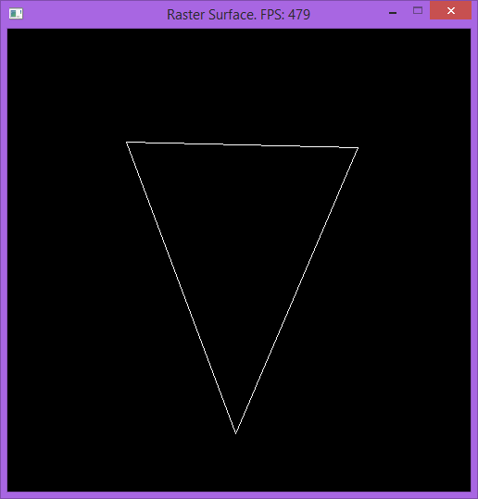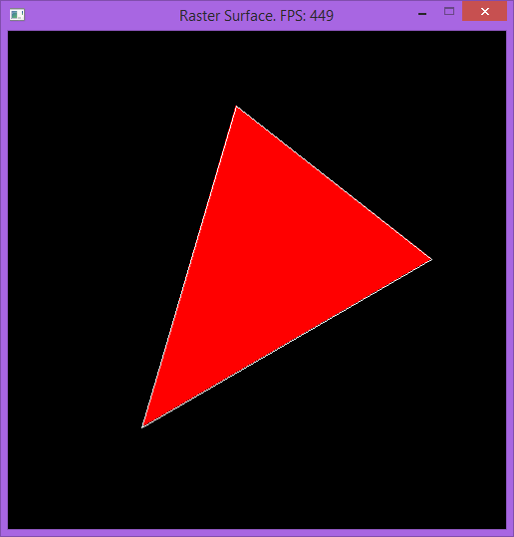

100%

